
beach and bike
VETRIDE KILCUNDA 2017
Oceanview Holiday Resort
3560 Bass Highway, Kilcunda VIC 3995
03 5678 7260 www.kilcundaoceanview.com.au

dates: check in Thursday 2nd March 2017, Friday 3rd, Saturday 4th, Sunday 5th, depart Monday 6th
format: return to base
rides: Bass Coast Hills and Rail Trail

www.vetride.org/

Younger Veterans Family Day

As a younger veteran or current serving ADF member, you and your family are cordially invited to join us for a day of comradeship and relaxation by the beach.

VetRide is made up of wide ranging age groups of enthusiastic veterans; ADF ex-members, supporters, family and friends, who share a connection between Service and fitness through cycling.

The organization is supported by government and ex-service organisations, including the Vietnam Veterans Association of Australia.

We have set aside Saturday 4th March 2017 as a day dedicated to the recognition and support of you, our younger compatriots; and to that end the day will provide an opportunity to meet, in a seaside environment over a catered lunch, provided by us.

The venue is located right beside the Bass Coast Rail trail, so don’t forget to bring your (and the kids) bikes.

If you would like to participate in the ride or just come along for the one day, please contact Secretary, David Price vetride@vvaavic.org.au or me liefman1948@gmail.com; and don’t forget your bathers.

Peter Liefman
Chair VetRide

KILCUNDA

The small community of Kilcunda is situated on the pristine and rugged South Gippsland coastline between Phillip Island and Wonthaggi. The commercial centre of Kilcunda is situated along the northern side of the Bass Highway and includes a hotel, general store and a small selection of other shops. Across the road is a coastal reserve perched above the beach on the clifftop, consisting of a caravan park, BBQ shelter and picnic areas, all offering scenic views towards the ocean.

There are three distinct beach areas in Kilcunda. The main town beach across the road from the shops and below the caravan park consists of wide stretches of sand with steep cliff backdrops and rocky platforms with shallow rock pools that extend into the sea. Shelley Beach is a secluded sandy beach bounded by two rocky headlands, accessed from either the Bass Highway west of Kilcunda Ridge Road or by walking around the western headland from the main beach. Past the eastern headland at the main beach is the town's surf beach, popular with anglers and surfers. Here, the rocky cliffs give way to a backdrop of large sand dunes and wide expanses of sand.

One of Kilcunda's best kept secrets is the Powlett River, accessed from the Mouth Of Powlett Road, 3 kilometres east of town on the Bass Highway. Fishermen frequent the area around the river crossing and also further along the river where it swells into what resembles a large lake. Safe, sheltered swimming and boating can be enjoyed in the river's shallow waters as it approaches the ocean at the Kilcunda-Harmers Haven Coastal Reserve. Sand dunes rise high above the river mouth, offering scenic views back along the river and of the wind-swept ocean beach.
The Bass Coast Rail Trail follows the route of the former railway line which connected Nyora with the coal mine at Wonthaggi. One of the best known features along this walking and cycling track is the railway trestle bridge over Bourne Creek which was built in 1910 and offers a spectacular vantage point, providing views of the surf beach below and to the hilly inland grazing areas. Another scenic track is the 7 kilometre long George Bass Coastal Walk which offers panoramic coastal views from a narrow winding path as it follows the coastline from the end of Punch Bowl Road in San Remo to the Kilcunda foreshore.

A drive several kilometres northwards along the unsealed Kilcunda Ridge Road takes visitors into the surrounding rolling hills where picturesque views of the coast from surrounding grazing land can be enjoyed.

There is plenty to see and do in the Bass Coast Region and on nearby Phillip Island http://visitbasscoast.com.au/



25 Veterans Drive,
Newhaven, Phillip Island VIC 3925
Phone: (03) 5956 6400

Off Road Cycling - Bass Coast Rail Trail
Type: | Rail trail
Location: | 130km south-east of Melbourne, near Phillip Island
Start/end: | Wonthaggi - The old railway station, located by the nearby mine tower head to Anderson - The carpark opposite the roundabout turn-off for Phillip Island
Status: | Open
Length open: | 23km
Surface: | Fine gravel
Terrain: | Flat from Wonthaggi to Kilcunda, then easy climb to Anderson

We are home to one of Victoria's coastal rail trails which offers panoramic views of Bass Strait from the Bourne Creek Trestle Bridge at Kilcunda. The Trail meanders through farmland, coastal bushland, historic coal mining reserves and rugged coastline. The Bass Coast Rail Trail links to the George Bass Coastal Walk at Kilcunda, so it is possible to walk from the Punch Bowl in San Remo all the way to the centre of Wonthaggi.
The Trail starts at the old Wonthaggi Railway Station in Murray Street or at the old Anderson railway station site on Bass Highway at the roundabout to Phillip Island. An extension of the trail from Anderson to Woolamai is suitable for walkers and horse riders only.
If you are bringing a large organised group along the Trail you should ring us before organising the event to make sure that the Trail is available and is not being used for another organised event. Contact our Arts and Leisure Team on 1300 BCOAST (226 278).
More information and maps are available on the Rail Trail's Website, in our Bass Coast Rail Trail Brochure (1.4MB) or by contacting our Arts and Leisure team on 1300 BCOAST (226 278).

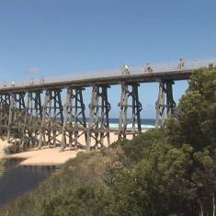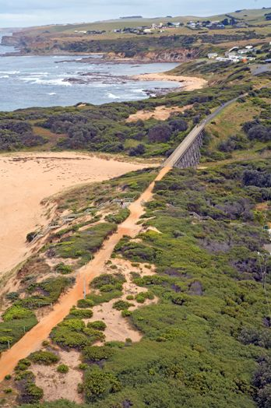

Road Cycling

The Bass Coast hinterland has undulating hills and quiet roads that are suitable for those who prefer road cycling.

